**Components of Communication Process**

Communication is a process of exchanging verbal and nonverbal messages. It is a continuous process. Pre-requisite of communication is a message. This message must be conveyed through some medium to the recipient. It is essential that this message must be understood by the recipient in same terms as intended by the sender. He must respond within a time frame. Thus, communication is a two way process and is incomplete without a feedback from the recipient to the sender on how well the message is understood by him.

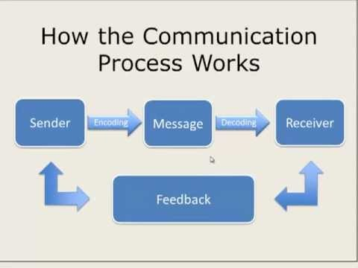

The main **components of communication process** are as follows:

1. **Context -** Communication is affected by the context in which it takes place. This context may be physical, social, chronological or cultural. Every communication proceeds with context. The sender chooses the message to communicate within a context.
2. **Sender / Encoder -** Sender / Encoder is a person who sends the message. A sender makes use of symbols (words or graphic or visual aids) to convey the message and produce the required response. For instance - a training manager conducting training for new batch of employees. Sender may be an individual or a group or an organization. The views, background, approach, skills, competencies, and knowledge of the sender have a great impact on the message. The verbal and nonverbal symbols chosen are essential in ascertaining interpretation of the message by the recipient in the same terms as intended by the sender.
3. **Message -** Message is a key idea that the sender wants to communicate. It is a sign that elicits the response of recipient. Communication process begins with deciding about the message to be conveyed. It must be ensured that the main objective of the message is clear.
4. **Medium -** Medium is a means used to exchange / transmit the message. The sender must choose an appropriate medium for transmitting the message else the message might not be conveyed to the desired recipients. The choice of appropriate medium of communication is essential for making the message effective and correctly interpreted by the recipient. This choice of communication medium varies depending upon the features of communication. For instance - Written medium is chosen when a message has to be conveyed to a small group of people, while an oral medium is chosen when spontaneous feedback is required from the recipient as misunderstandings are cleared then and there.
5. **Recipient / Decoder -** Recipient / Decoder is a person for whom the message is intended / aimed / targeted. The degree to which the decoder understands the message is dependent upon various factors such as knowledge of recipient, their responsiveness to the message, and the reliance of encoder on decoder.
6. **Feedback -** Feedback is the main component of communication process as it permits the sender to analyze the efficacy of the message. It helps the sender in confirming the correct interpretation of message by the decoder. Feedback may be verbal (through words) or non-verbal (in form of smiles, sighs, etc.). It may take written form also in form of memos, reports, etc

Source: <https://www.managementstudyguide.com/components-of-communication-process.htm>

